CS550 Big Data Analytics and apps

Using the same program in lab2 We generated text files in the device

Viz: Training Punch.Txt, Training LR.txt,TrainingRL.txt, TrainingCombo.txt

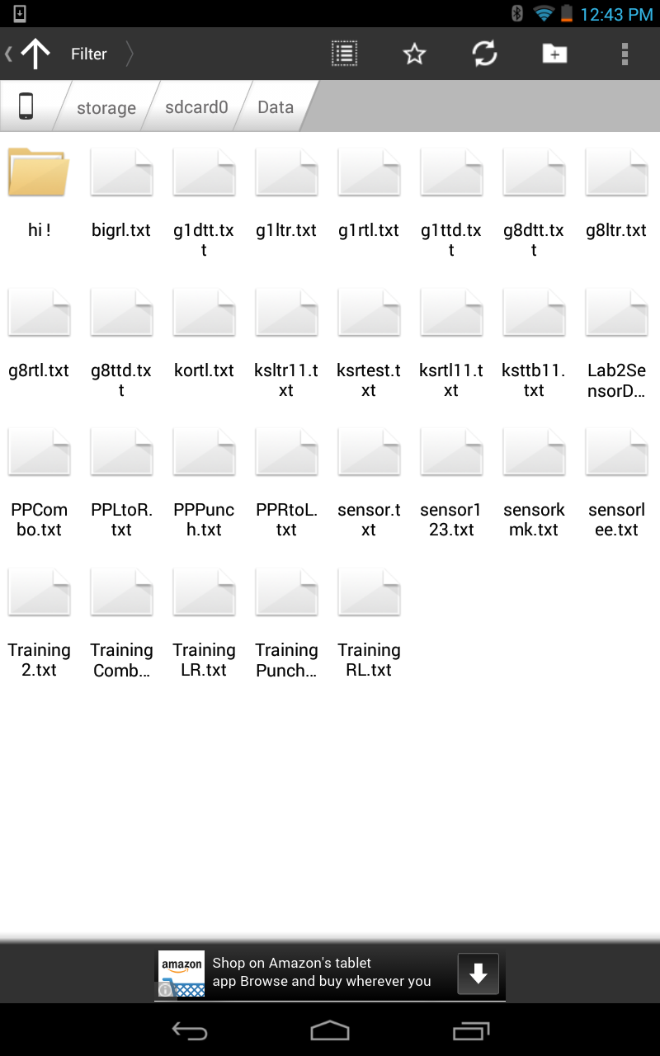

Using winscp I uploaded these files to the Cloudera group9

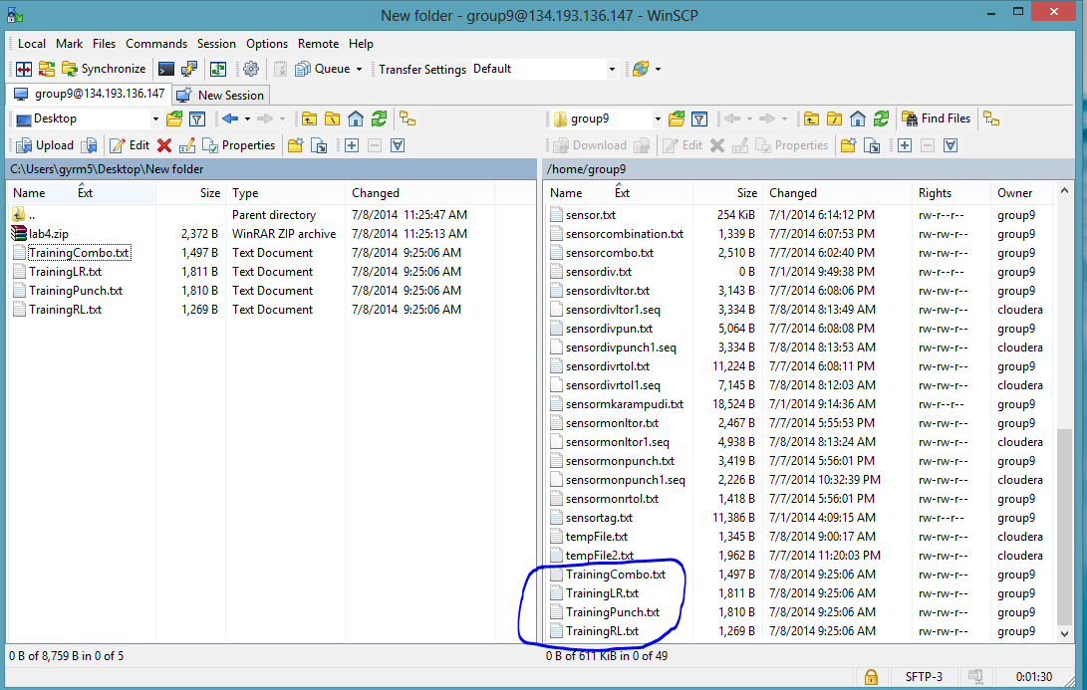

I checked the files in Cloudera using putty

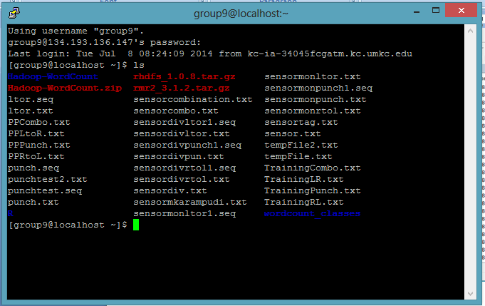

Then I used the web links to generate the sequence files by using android async task in which the background calls the link<http://134.193.136.147:8080/HMMWS/jaxrs/ge%20neric/TrainFileOperation/-home-group9-TrainingLR.txt/-home-group9-TrainingLR.seq>

And on post execute the text box displays the result of the sequence file generated and the activity recognized.

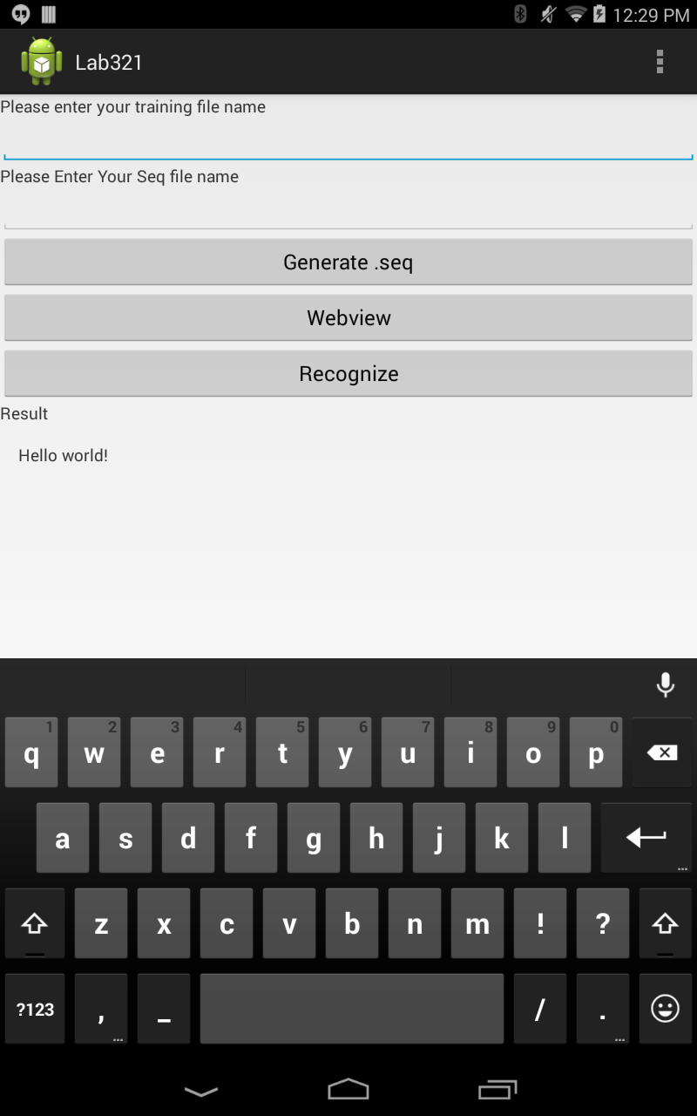

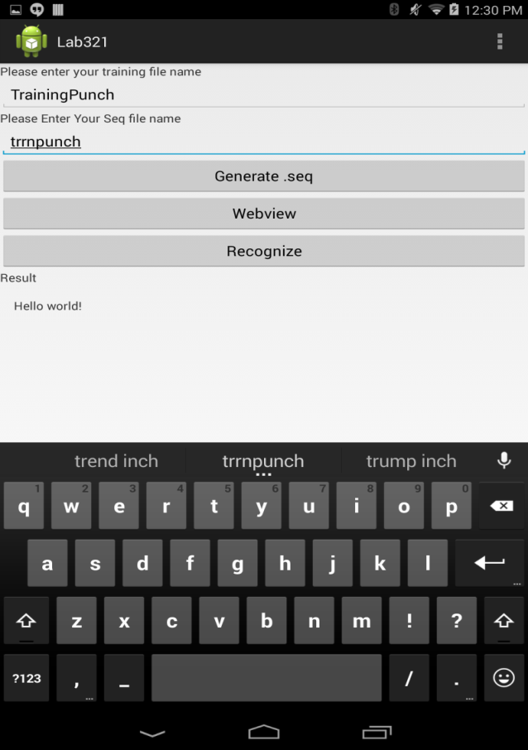

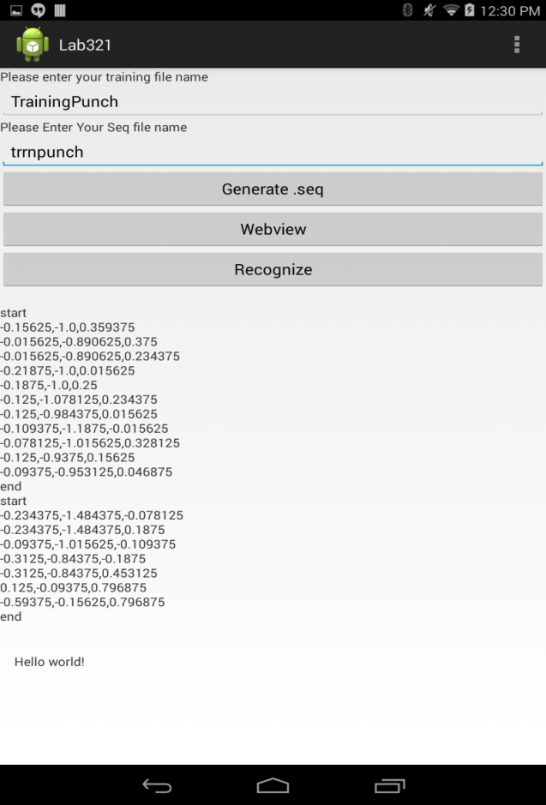

The generated seq file is checked via putty

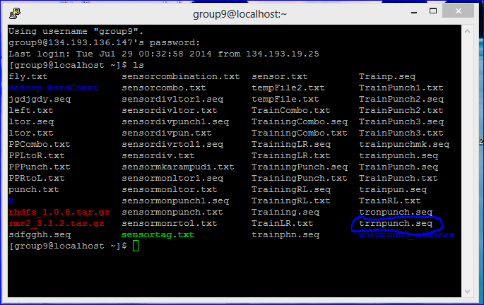

On Click of the recognize

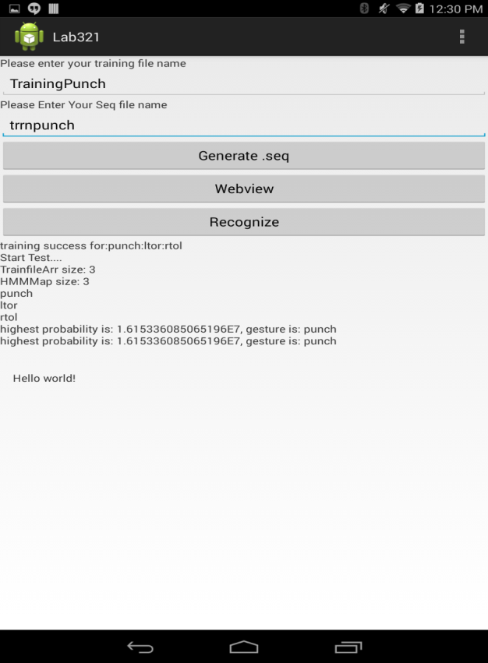

Using the program in the lab3 I have written save file on retrieve button click to save the file

